Instructions for author: writing an abstract to be submitted to CMIS2018

First A. Author, Presenting Author and Third B.C. Author

Write affiliation here. If you need more than one affiliation use numbering.

Summary: Here you provide a 50 words summary of the manuscript, typed in 12pt, justified at both margins. Both left and right margins are indented by 0.64 cm (0.25 inches) with respect to the document margins.

Introduction
This document will help you prepare your abstract (maximum 2 pages) for CMIS2018. All instructions for lay-out and style are provided, and at the same time, this document will serve as an example as all instructions are applied to write it. We encourage you to save this document under a different name, to delete all text and to use the empty document to write your extended abstract. The document template contains all the necessary styles and page set-up and is ready to use. Avoid individual formatting of headings and text as much as possible. Use the paragraph styles as defined in this document to format the lay-out of your abstract. The abstract may contain figures (see for example Figure 1), tables, equations and references.
Note that uploaded abstracts must be in PDF format, not larger than 3 MB!

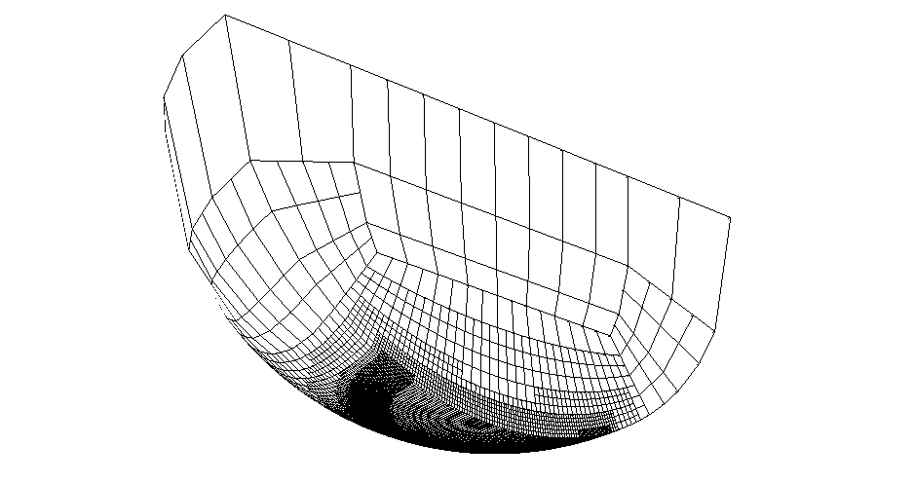 | 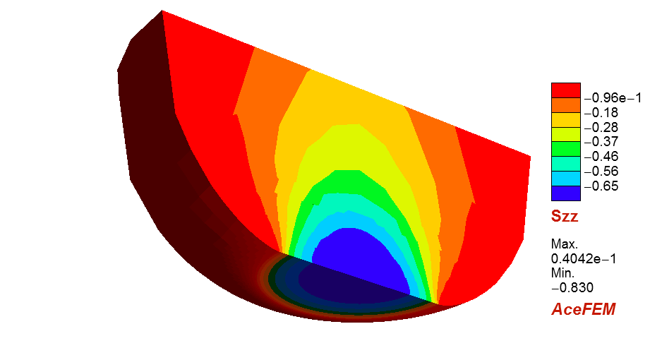
(a) | (b)
Figure 1: Soft-EHL problem: (a) finite element mesh in the undeformed configuration, (b) σ_{zz} component of the Cauchy stress tensor in the deformed configuration.

Lay-out and style
Page set-up
Use A4 paper with top and bottom margins of 2.54 cm (1 inch) and left and right margins of 3.17 cm (1.25 inches). Do not include page numbers or any other page header or footer. Footnotes are not allowed.
Font
Times.
Title
The title is typed in bold, 14pt, centered. Do not capitalize words in the title, except the first word of the title or proper nouns. Between title and authors list there is a blank line.
Authors
The authors are listed in one paragraph in 12pt, centered. Put first name, initials and last name (see example above). Use superscripted numbering if authors have a different affiliation.
Affiliation
Affiliation and e-mail address are in 10pt, italic, centered. Different affiliations are put in separate paragraphs and numbered with the superscripted numbers used in the authors list. If no e-mail address is available, add a fax-number.
Body text
In the remaining sections of the abstract, headings are formatted in LATEX according to their ranking with paragraph formats ‘section’ and ‘subsection’ (see Table 1). One additional level, namely ‘subsubsection’, is allowed but should be used sparingly. Text paragraphs are not numbered and are justified at both left and right margins and in 11pt.
Table 1: Formatting used in paragraph headings.
Heading type | Font size | Font style
Section | large (12pt) | bold
Subsection | large (12pt) | italic
Subsubsection | large (12pt) | standard

References
All publications cited in the text should be numbered between brackets (e.g. [1], [2, 3]) and listed in numerical order following the text of the manuscript. Work accepted for publication but not yet published should be referred to as “in press”. References concerning unpublished data and “personal communications” should not be cited in the reference list but may be mentioned in the text.
References
[1] P. Wriggers. Computational Contact Mechanics, 2nd ed., Springer, 2006.
[2] G. Zavarise, P. Wriggers, Contact with friction between beams in 3-D Space, Int. J. Num. Meth. Engng., 49:977-1006, 2000.
[3] T. Laursen and J.C. Simo, A continuum-based finite element formulation for the implicit solution of multibody, large deformation frictional contact problems, Int. J. Num. Meth. Engng., 36:3451–3485, 1993.

